


9-7/8" Hole Section
IJN 8-1

Performance Report
Rig Hour
MITRA Real Time Resolution Center
(MITRA RC)
Well Name | Rig Name | Section | Field | Spud Date | Midnight Depth
IJN 8-1 | EPI-09 | 9-7/8” | Ijen | Oct, 08-2023 | 2666 mMD
DAILY OPERATION SUMMARY:

Drilling Formation to 2666 mMD 2601.63 mTVD. Circulate Hole Clean prior to Short Trip.

Break Down Time vs Depth

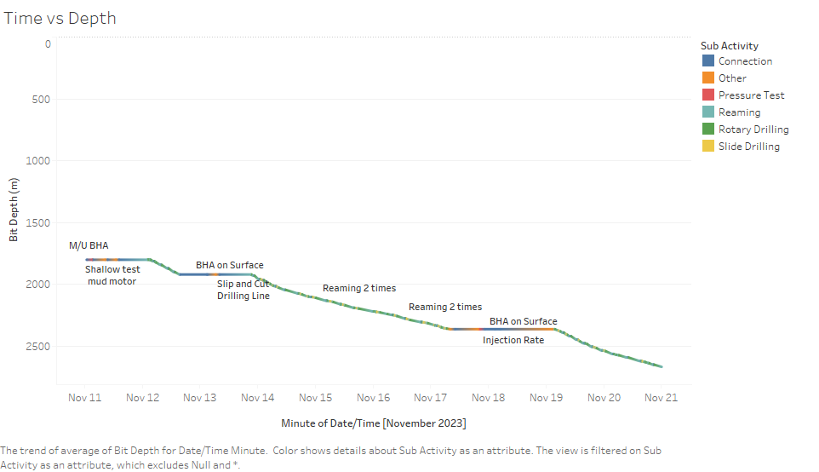
Break Down Rig States:
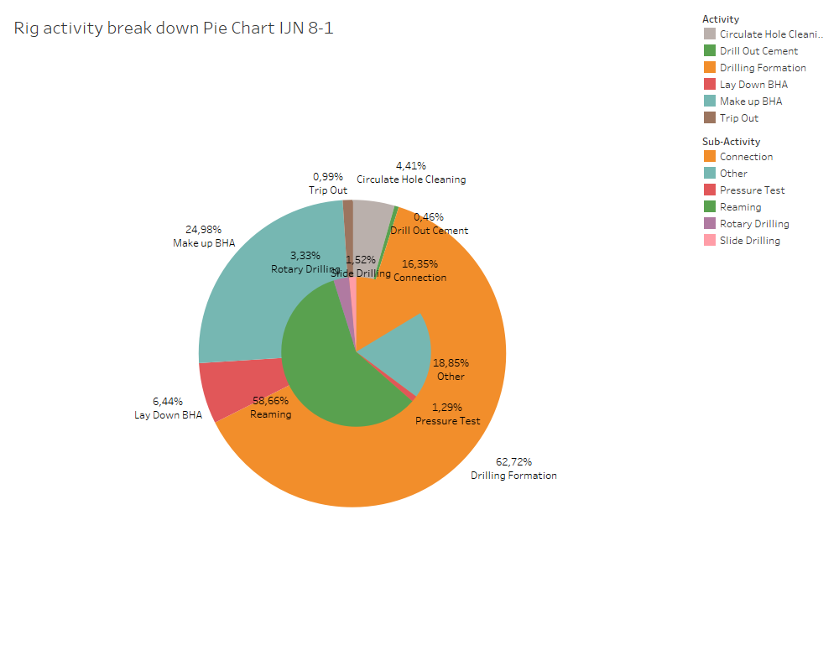

Daily Drilling Meterage:

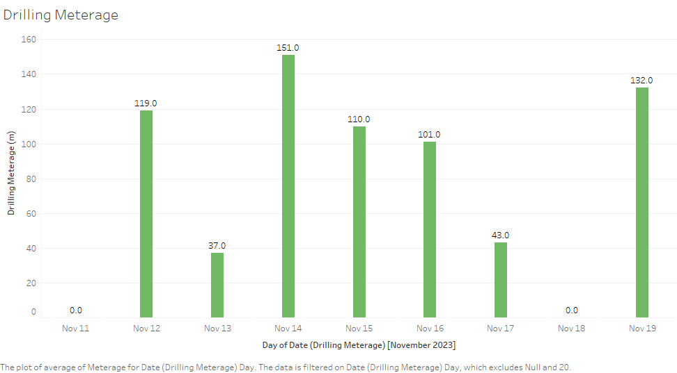
Stand Time Distribution by Well:

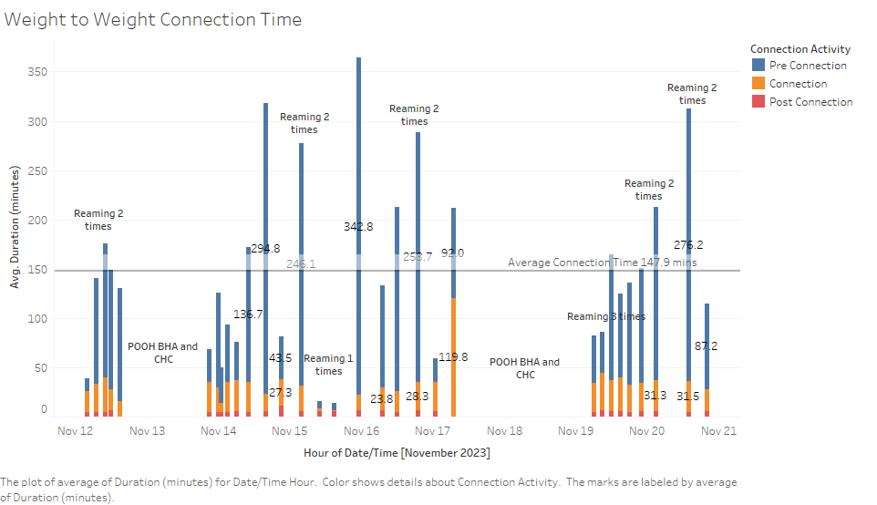

Stand Time Distribution:

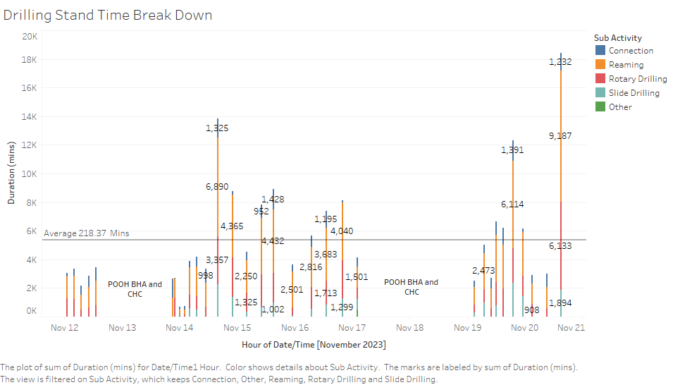

ROP on Bottom vs Stand ROP Breakdown:

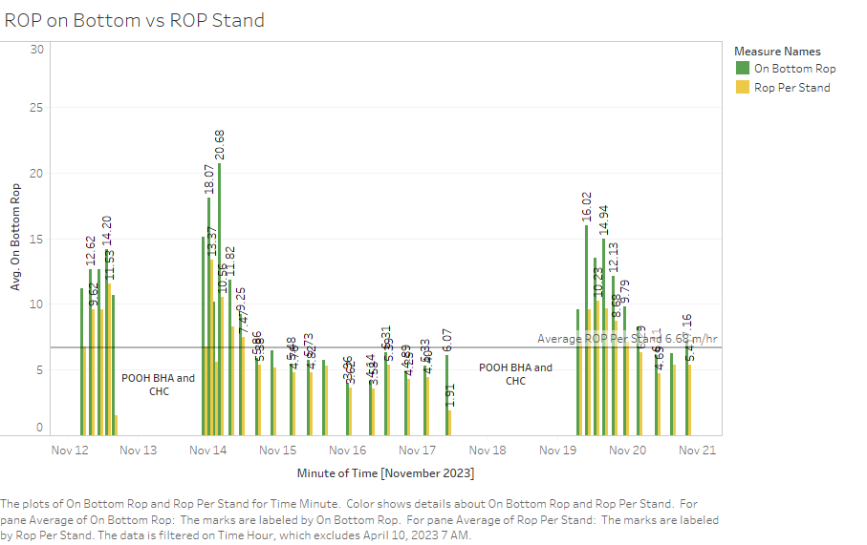

BHA Trip Breakdown:

